**Problem with Backends**

* If we use the backends using same template for managing different environments will be tricky.
* When user 1 tries update Dev it should not stop user 2 to update QA environments  
  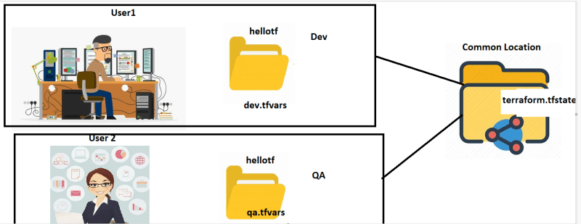
* The basic idea is to use the same template across environments
* Terraform has workspaces

**Terraform workspaces:** With the help of terraform workspace we can manage multiple environments with one configuration. [Somewhere similar to git branching]**.**

* <https://developer.hashicorp.com/terraform/language/state/workspaces> for workspaces docs and <https://developer.hashicorp.com/terraform/cli/commands/workspace> for terraform workspaces cli
* Terraform by default assumes the current workspace is default  
  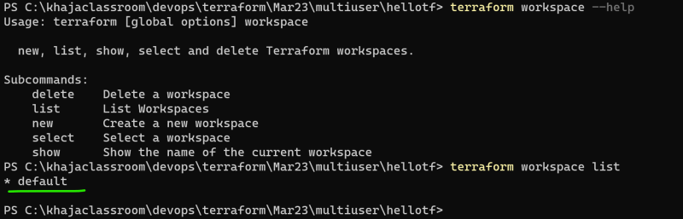
* Let’s create a workspace called as dev by user 1  
  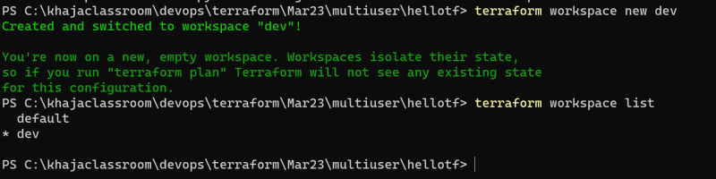
* <https://github.com/asquarezone/TerraformZone/commit/cc438f3ecfe71fd80a7de99f5165af36d83f8fcf> for changes done
* Now let’s create dev environment and apply the changes from user1 and created the qa environment and apply the changes from user 2.
* Terraform will allow both the users to create in parallel.  
  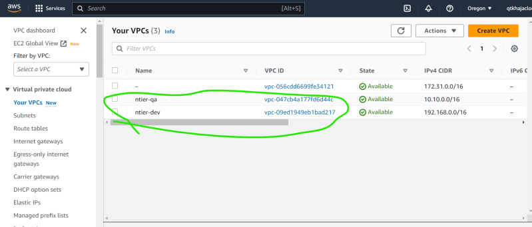
* Used conditional expression for creating a bastion subnet in qa <https://github.com/asquarezone/TerraformZone/commit/82052226729ea4c070956a3169cec3ffad1108d6> for changes and <https://developer.hashicorp.com/terraform/language/expressions/conditionals> for conditional expressions in terraform
* Terraform allows multiple environments from one template with workspaces

**Problem**

* <https://github.com/asquarezone/TerraformZone/commit/d88ce8fbdcdf56e405c9f09d4c24229a6f4896d8> for the change which used count to create three files
* Now let’s make a small change <https://github.com/asquarezone/TerraformZone/commit/d88ce8fbdcdf56e405c9f09d4c24229a6f4896d8> where the second item from list is removed
* now apply to see the plan  
  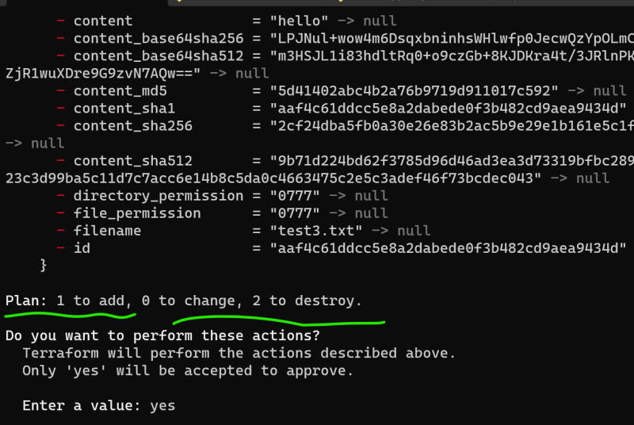
* Terraform is deleting test2.txt and test3.txt also and then creates test3.txt again to maintain state
* To solve this problem, we can use for_each <https://developer.hashicorp.com/terraform/language/meta-arguments/for_each>
* Exercise: Try solving the above problem with for_each

**Interpolation in terraform**

* Interpolation can be acheived by using format function or ${var} expresssion  
  